**Welcome to DIGITAL LIBRARY HELP**

 After installing the The digital library. In start manu you get digital library installed file with this icon .then u click on this icon and then the digital library home page is appear in your computer screen.

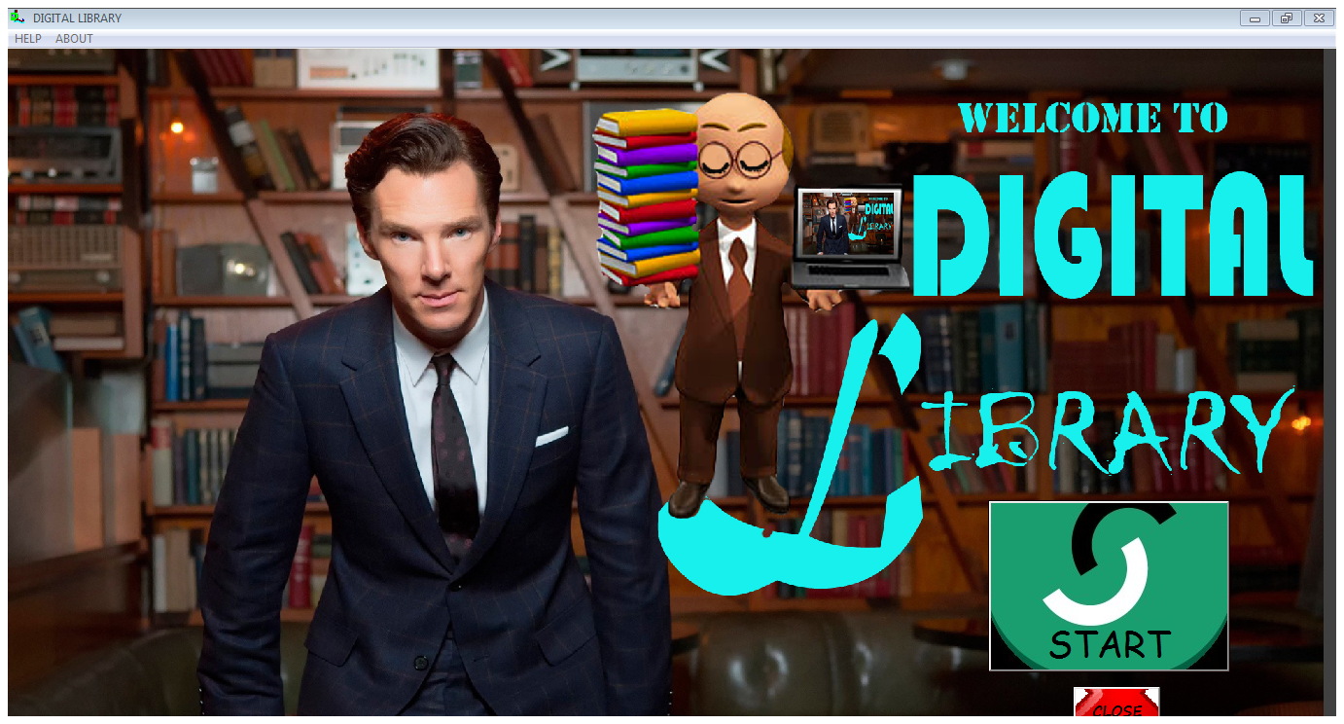 then click On start button to continue the programme then the log in page appear in your screen .If you have a username and password then fill the blanks

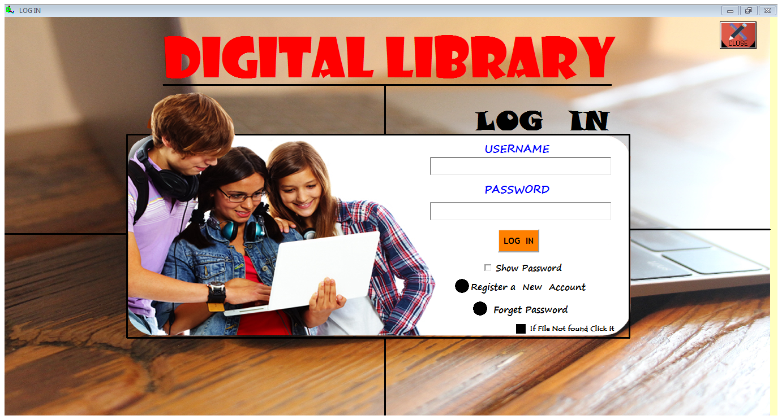

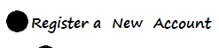If you have no username and password then u need to create a new digital account by clicking the register of a new account

And then the blank fill of your new account is appear

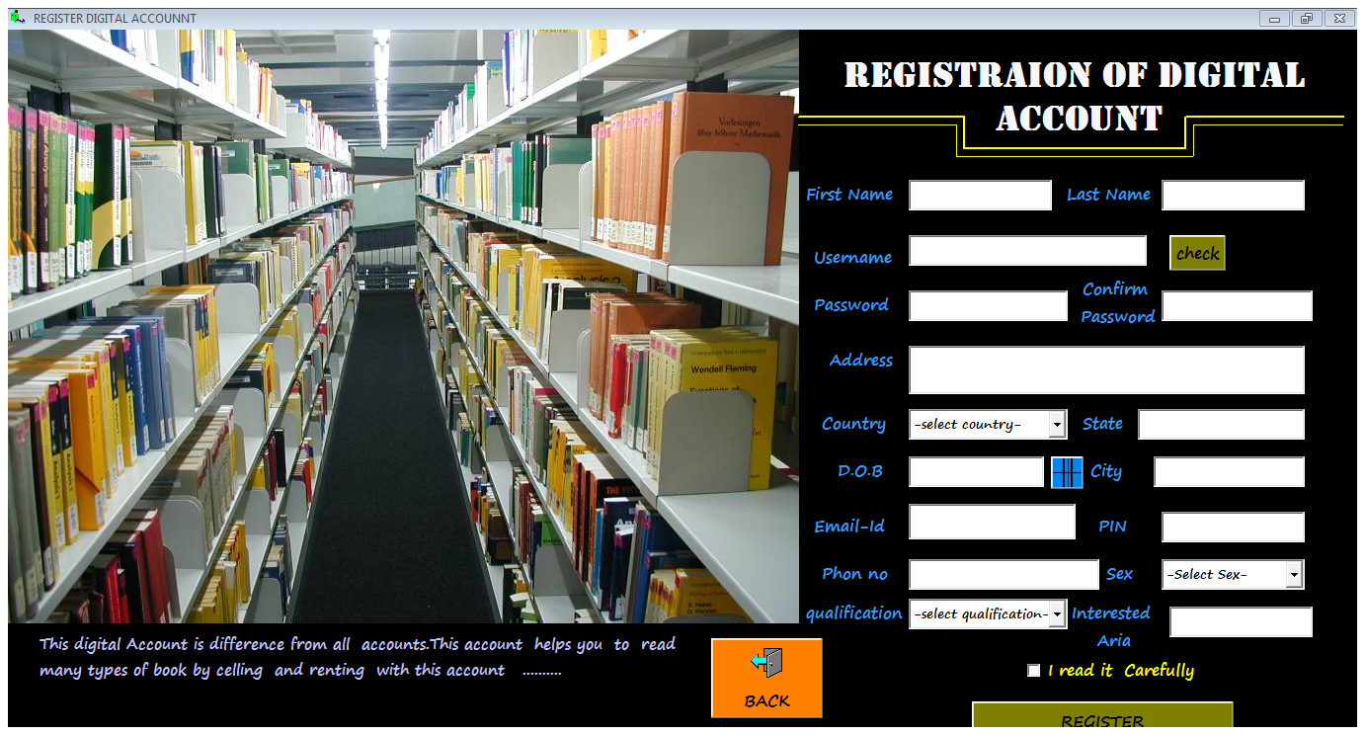here you give all of your data and then click on I read it carefully and then register after this registration u will be able to log in this digital library account. Then click log in and you riches in the main page of digital library and here I use my own id as prosandy03 and then my main page show as

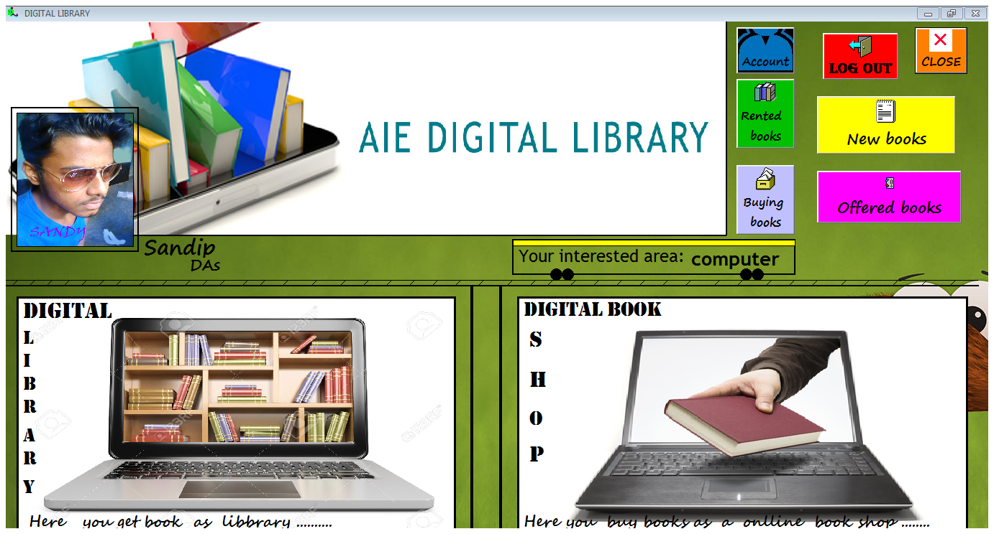

If you want to get books rent then click on digital library box and the book stall is appear in your screen .Then chose your book category.

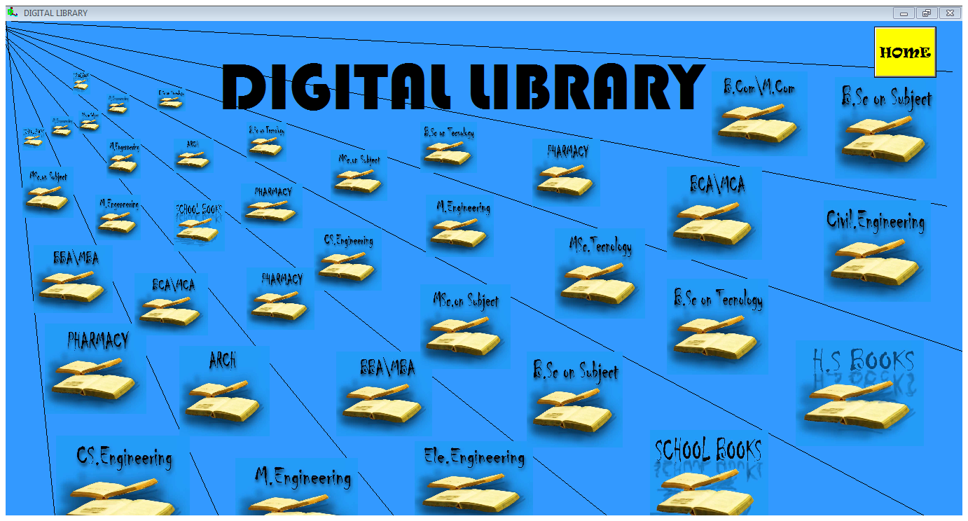

Here I chose h.s books then the h.s books stall is appear in your screen then chose your particular two books

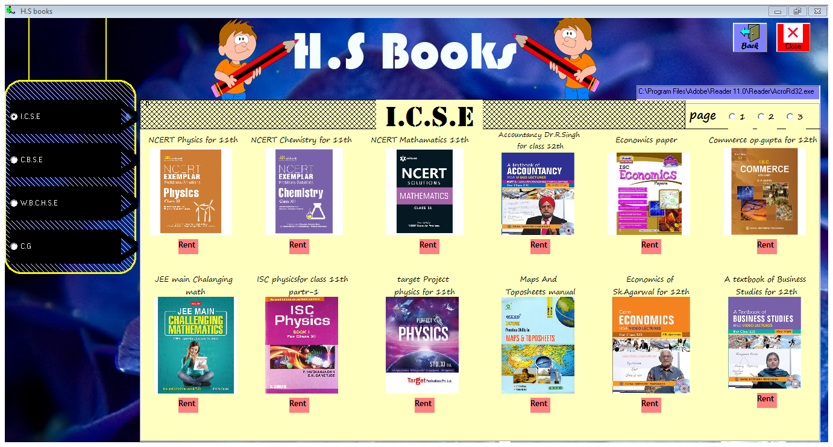 here you get many boards book like I.C.S.E, C.B.S.C,W.B.C.H.C.E and C.G. and then click on rent button to rent and your book is ready for rent .Here company create a rule that if you rent more then 2books then you can’t rent a another book without return this books.

Then click on the books pic to saw all the books index and more…

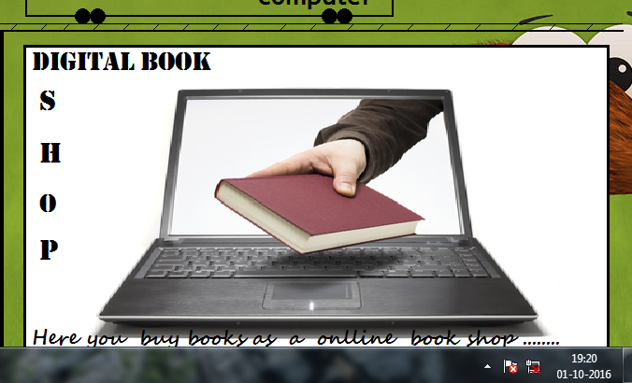Then again come to the home page and chose Digital book shop and then the

Book stall is ready to show all books here you chose the category of book and click on it then .as a demo I chose computer book here we can show many book related with computer

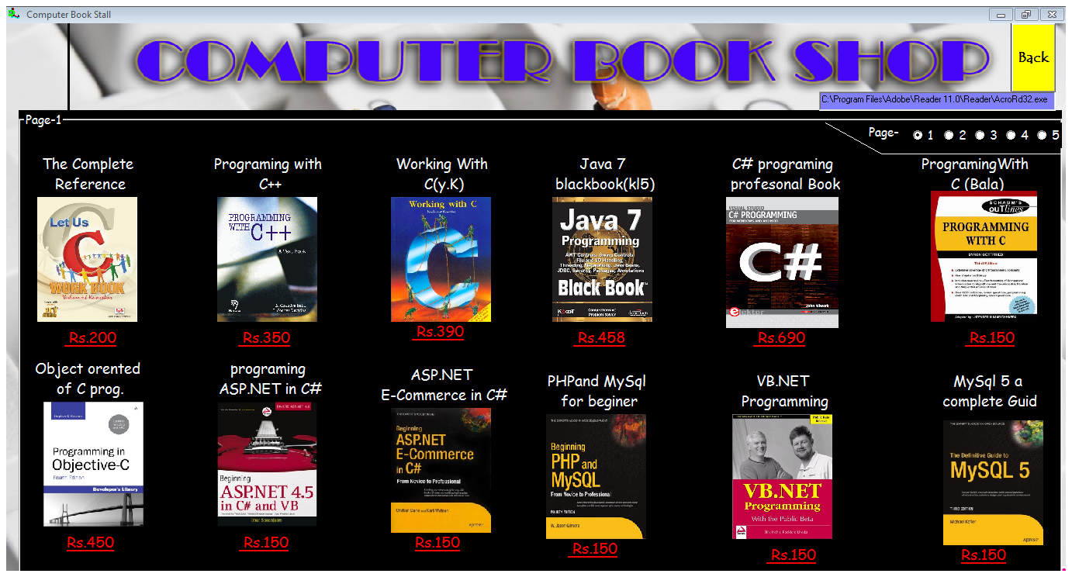

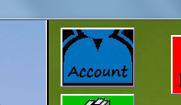Then click on the books pic to saw all the books index and more .and then click on the Rs. and you get an option to by hand or online if you chose online then you not need pay money in the delivery time .if you chose by hand then click on yes button and you need to pay on by hand when you get book manly.

To check your account details or need to change then click on the

Account button and then the page will show. Here if you want to change your data then click on the change mod and then the the date will changeable as you can.then click save to properly change.

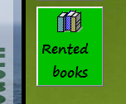if you want to show your ranted books then click on the ranted book option here you also can send request for return a book. Click on this button after chaking 1 or 2 books

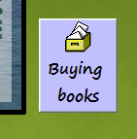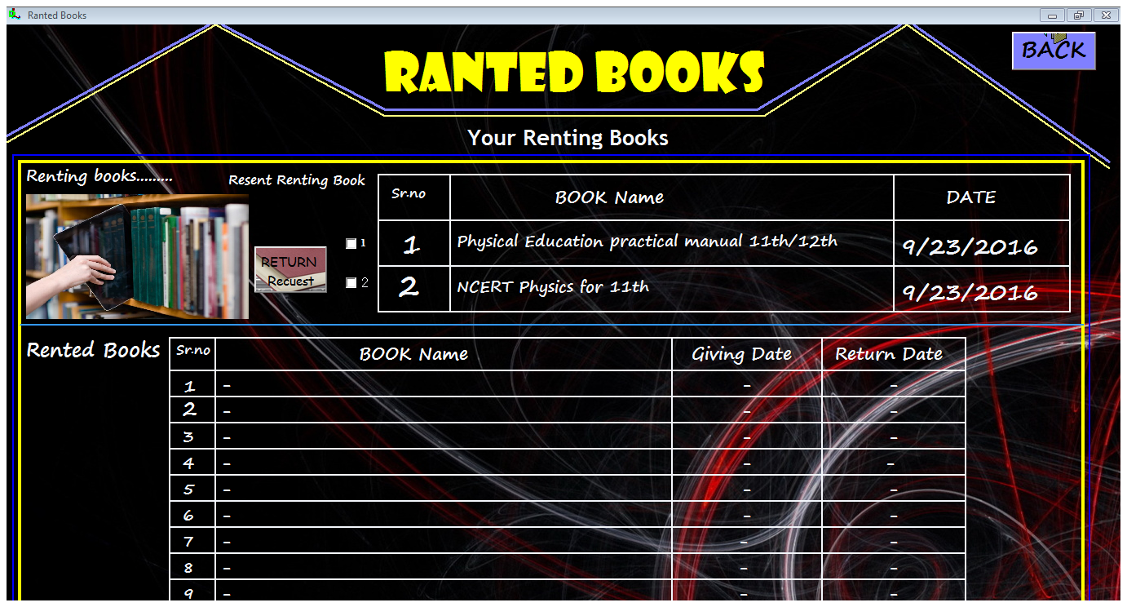then the other showable button is buying button if you click on it then you show your buying books. This page is only for showing the buying books.

To know more about this software you need to show its tutorial video on youtube of the link of <http://www.youtube.com/digital library using vb6.0>

And if you want to consult about this software developer then you need to met mr. Sandip Das of his gmail Account [prosandy03@gmail.com](mailto:prosandy03@gmail.com)

Thank you for Using **Digital libaray**